NIST 800-53 Compliance for Log360
Strengthen data protection and meet NIST 800-53 compliance with Log360.
Region: USA | Type: Data Privacy, Government/Public Sector, Industry Standard, Incident Management | Category: Compliance | Pricing: Free

Overview
The NIST 800-53 compliance extension in Log360 helps organizations meet NIST SP 800-53 Rev. 5, the comprehensive security and privacy controls catalog developed by NIST for US federal information systems and contractors by providing centralized log management, real-time threat detection, and cross-platform audit reporting. The platform supports NIST 800-53 requirements for access control, audit and accountability, configuration management, incident response, identification and authentication, system and information integrity, system and communications protection, privileged access management, and risk assessment.
For Access Control (AC), Log360 monitors logon events, failed authentication attempts, and account changes across Windows, Unix, and Active Directory, providing continuous evidence of access policy enforcement required by the AC control family. To address Identification and Authentication (IA), the platform tracks MFA authentication events, password policy modifications, and credential changes across identity platforms to verify compliance with IA authenticator management controls. The extension also supports Audit and Accountability (AU) by providing capabilities that captures Windows event logs, SQL Server and Oracle audit records, and Active Directory audit trails, supporting full traceability of all auditable events required by the AU control family.

Key Features
- Configuration Management: Log360 detects unauthorized registry modifications, monitors policy changes, tracks process execution, and audits software inventory to ensure configuration integrity across the environment.
- System and Information Integrity: Log360 aggregates antivirus, anti-malware, and endpoint threat data from Windows Defender, Trend Micro, and FireEye to provide continuous threat monitoring satisfying SI control requirements.
- Incident Response: Log360 detects incidents through correlated network attack reports, cloud security incident alerts, Microsoft Defender events, and backup system malware detection logs for rapid IR support.
- System and Communications Protection: Log360 monitors firewall rules, network device logons, attack traffic, and policy changes across routers, switches, firewalls, and VPN appliances to satisfy SC network protection requirements.
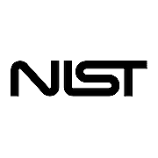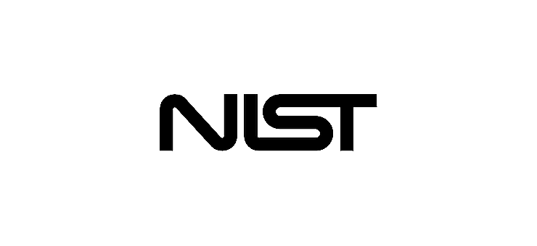

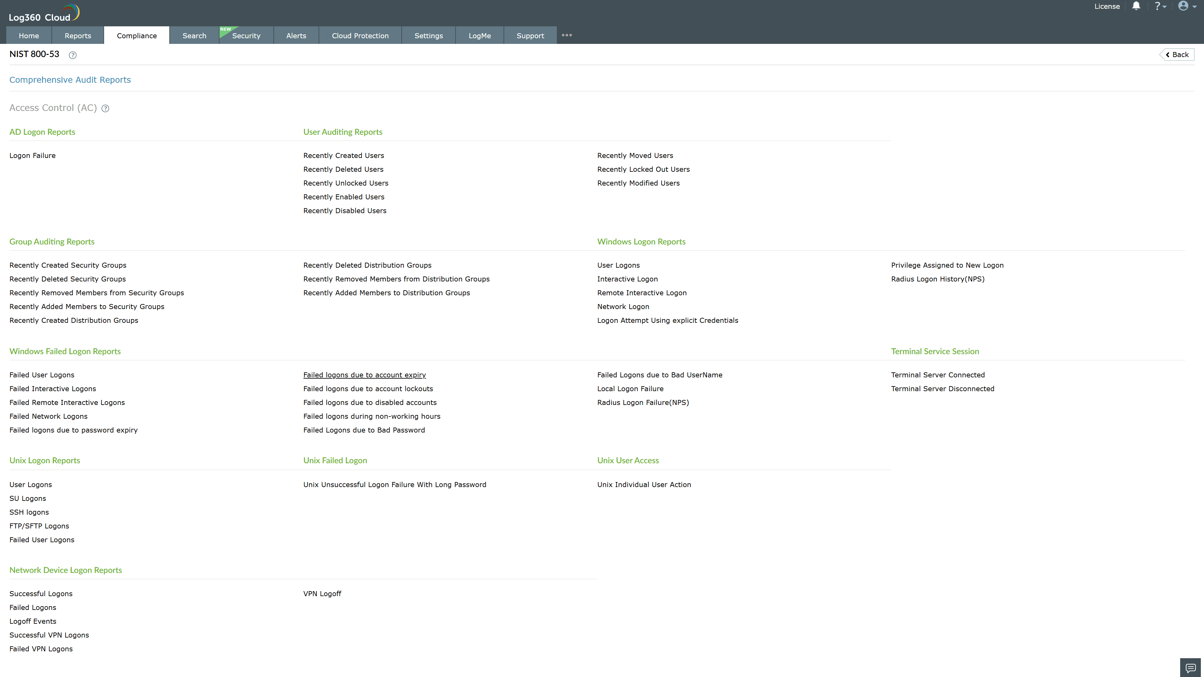
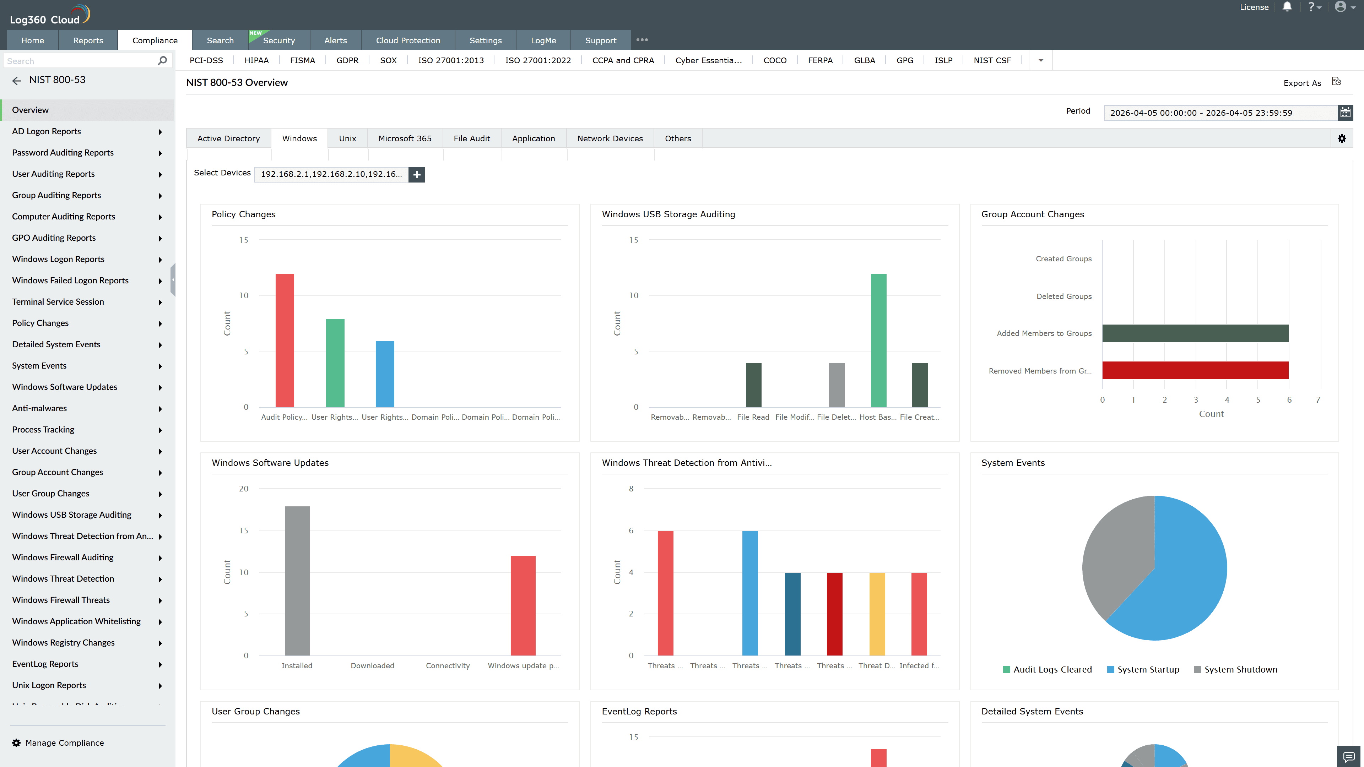
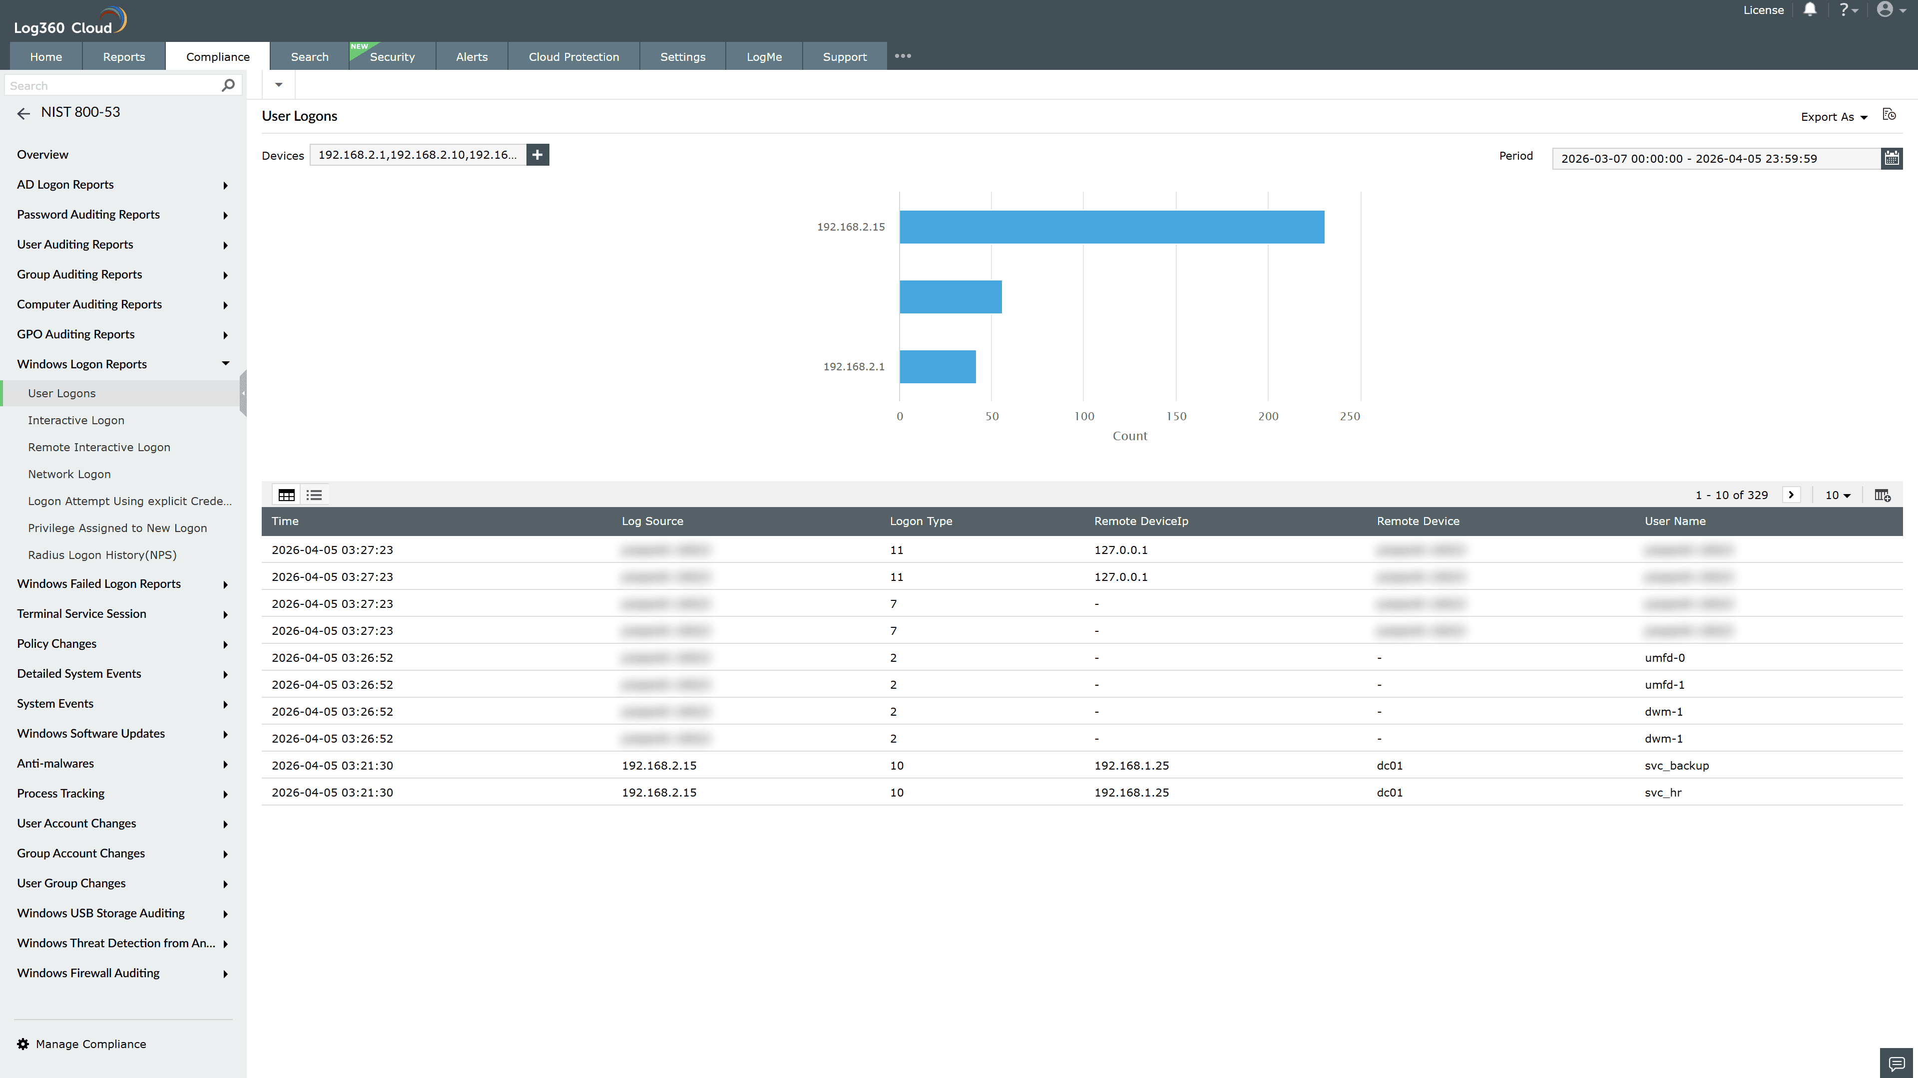
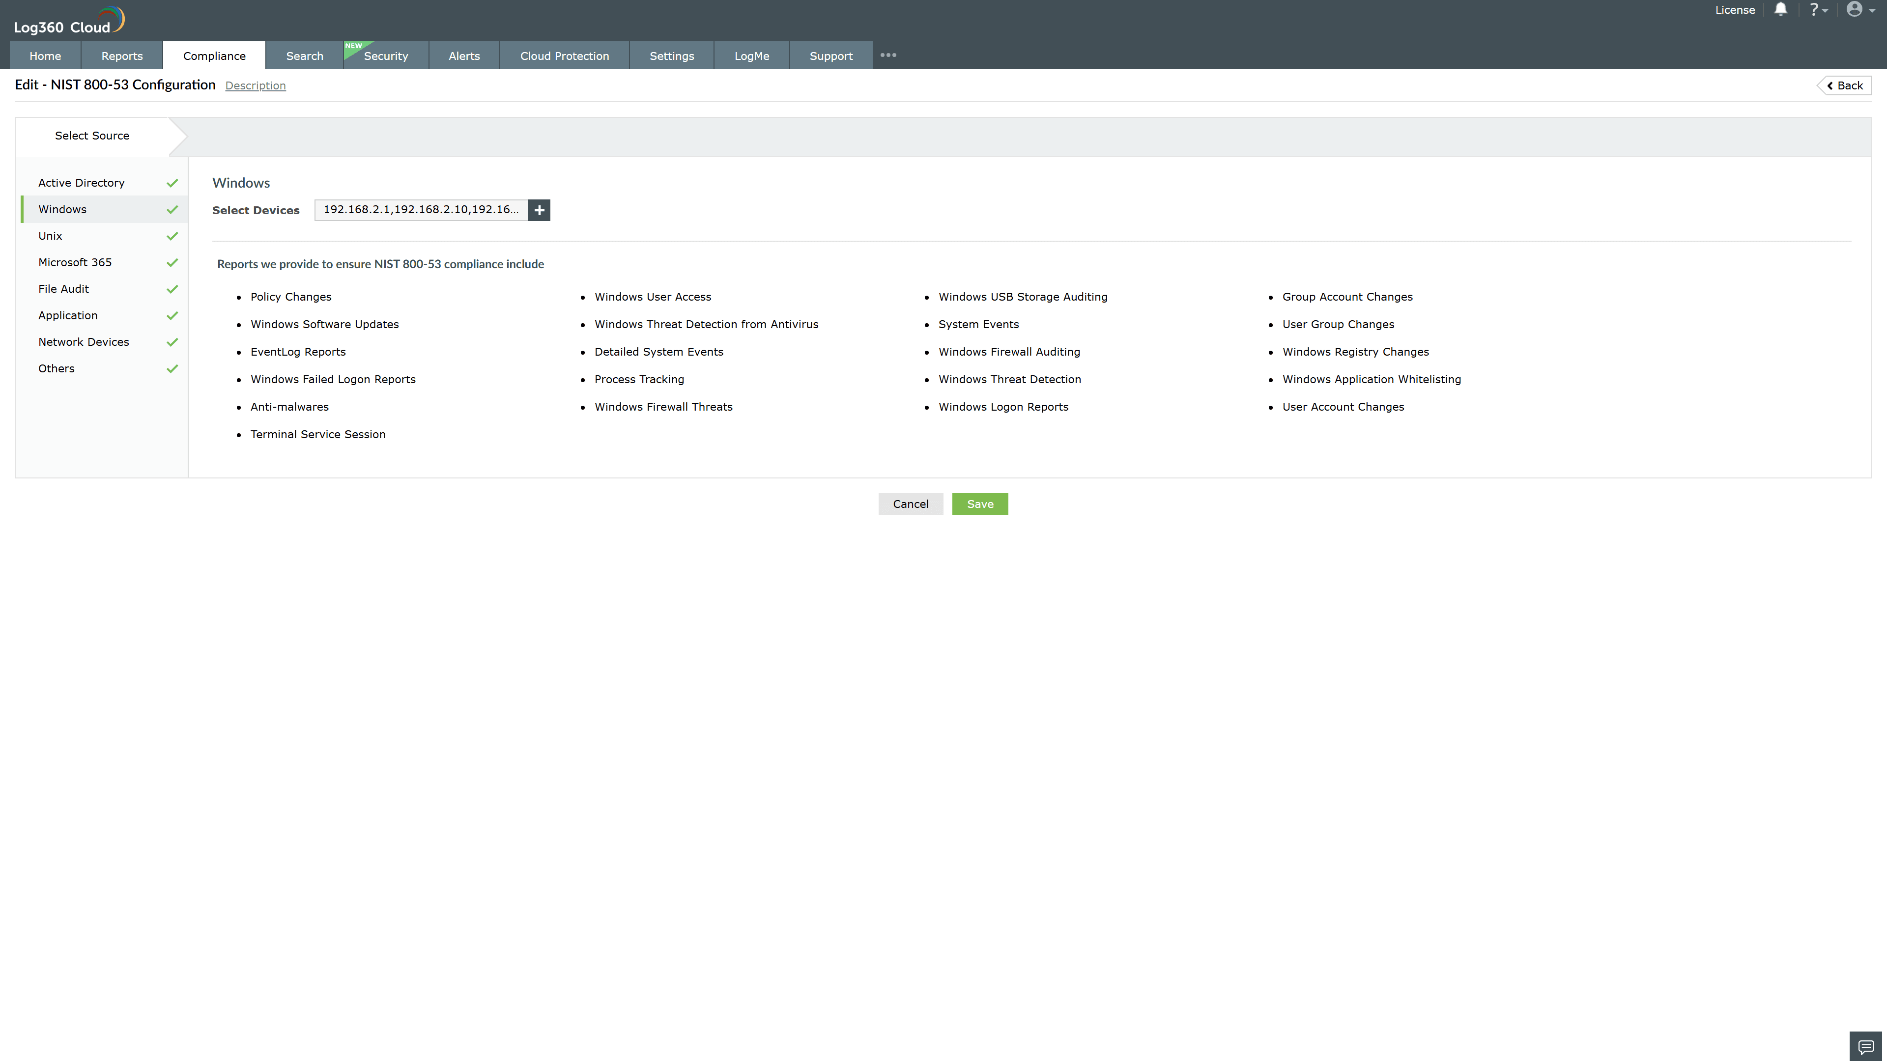
Valid Submission : Yes
Supported Editions : Free, Basic, Standard, Professional, MSSP
Help Document : https://www.manageengine.com/log-management/help/integrations/compliance-extensions.html
Help Video : Not provided
Tags : Log360, Compliance, Privacy monitoring, Data privacy, Regulatory compliance
Supported DCs : US, IN, JP, CA, AU, UK and EU
Privacy Policy:
Terms of Service:
Release Notes:
Predefined reports for the NIST 800-53.

